**Final Project Presentation**

**Introduction:**

The purpose is to help people in finding better locations in and around their neighborhood. People can make a logical and smart decision on selecting the perfect neighborhood for their needs in Scarborough, Toronto.

Lots of people are moving to Canada and needed lots of research for good housing prices and reputed schools for their children. This is for people who are looking for better neighborhoods. Most importantly trying to see the ease of access of various entities such as cafes, schools, parks, super markets, grocery shops, malls, theatres, and hospitals.

We will create an analysis of features of Scarborough in comparison to other neighborhoods. The features include median housing price and better school according to ratings, crime rates of that particular area, road connectivity, weather conditions, good management for emergency, water resources both fresh and waste water and excrement conveyed in sewers and recreational facilities.

**Problem and Reasoning:**

The problem that we are trying to address is to provide a better option for a new neighborhood for an individual to move into. We will consider all things, such as: distance to city center, airport, markets, and other needs.

My childhood best friend moved to Scarborough when I was younger. He told me that he really loved it there even though he missed New York City. Housing in Scarborough is cheaper and you don't really need a car to reside there. There is a lot of green space. Scarborough has been growing lately, with an influx of immigrants coming there.

**Tools to be Used:**

We will use the **Four-square API** because it acts as a database for various locations, especially their API which provides the ability to perform location search and details about businesses.

**Python Libraries**  
Geocoder  
Pandas  
Matplotlib  
Folium  
Scikit Learn  
JSON  
XML  
Beautiful Soup and Requests

**Data Description of Scarborough, Toronto**

**Description**

We will use the following link to access the Scarborough dataset. We will use the latitude, longitude, and zip codes. We worked with this dataset in Week 3 as well.

<https://en.wikipedia.org/wiki/List_of_postal_codes_of_Canada:_M>

**Foursquare API Data Description**

Foursquare is a location data provider with information about all manner of venues and events within an area of interest. Since all necessary information can be obtained through the API, we will only use Foursquare. We will need data about different venues in different neighborhoods of that specific borough.

After finding the list of neighborhoods, we connect to the Foursquare API to gather information about all the venues. For each neighborhood, we have chosen the radius of 100 meters.

The following is what we will obtain from Foursquare API:

1. Neighborhood
2. Neighborhood Latitude
3. Neighborhood Longitude
4. Venue
5. Name of the venue
6. Venue Latitude
7. Venue Longitude
8. Venue Category

Methodology Section

I used a K-Means Clustering Approach. I looked at the Most Common Venue.

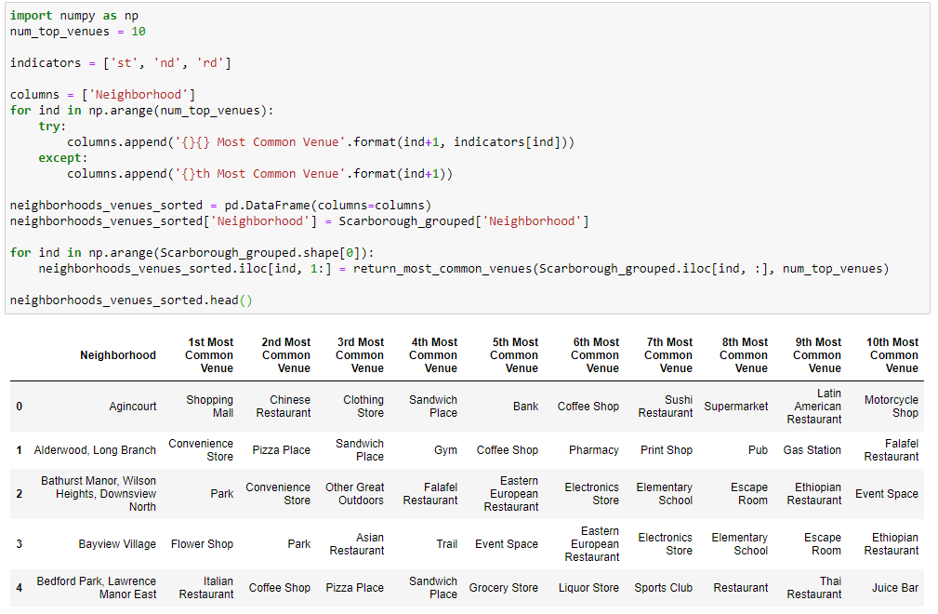

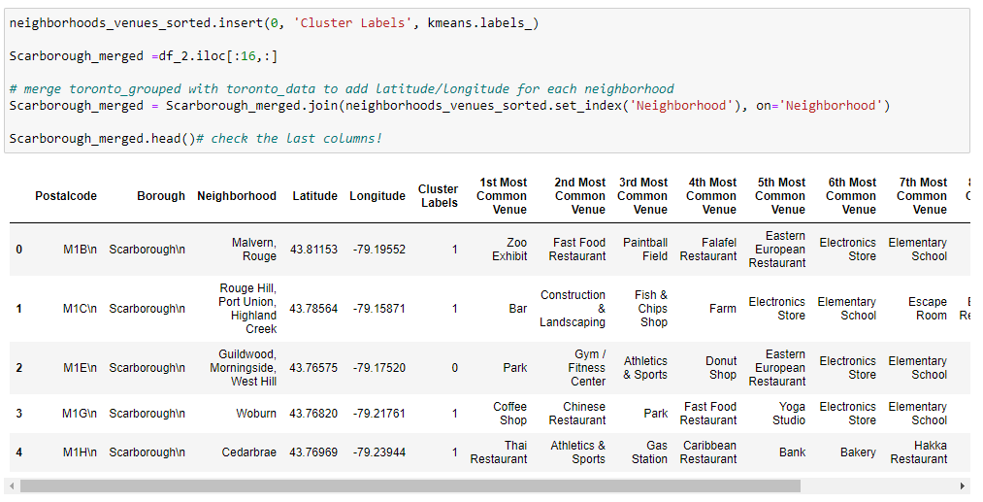

Results Section

Scarborough – Map of Clusters

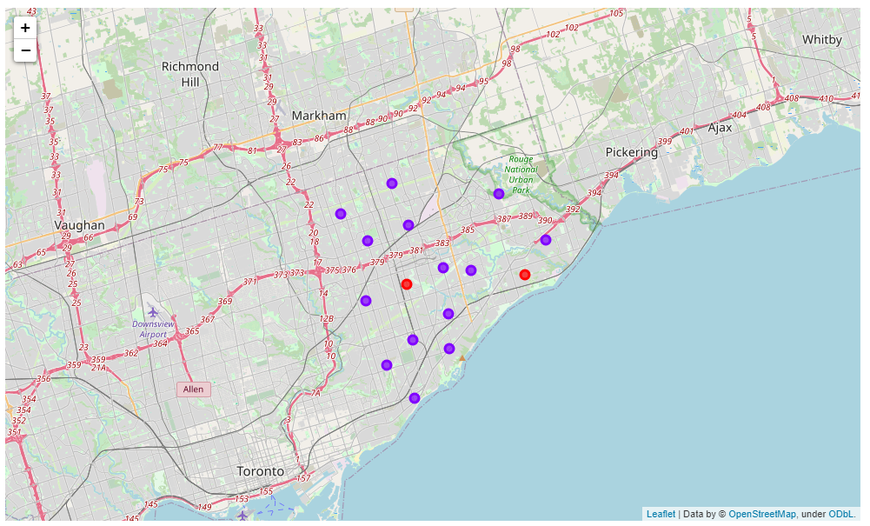

Average Housing Price

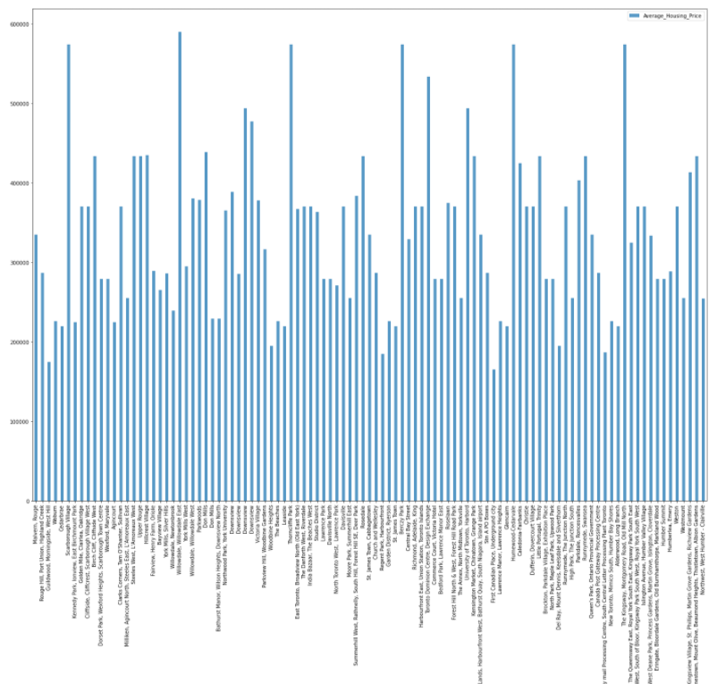

School Ratings by Clusters

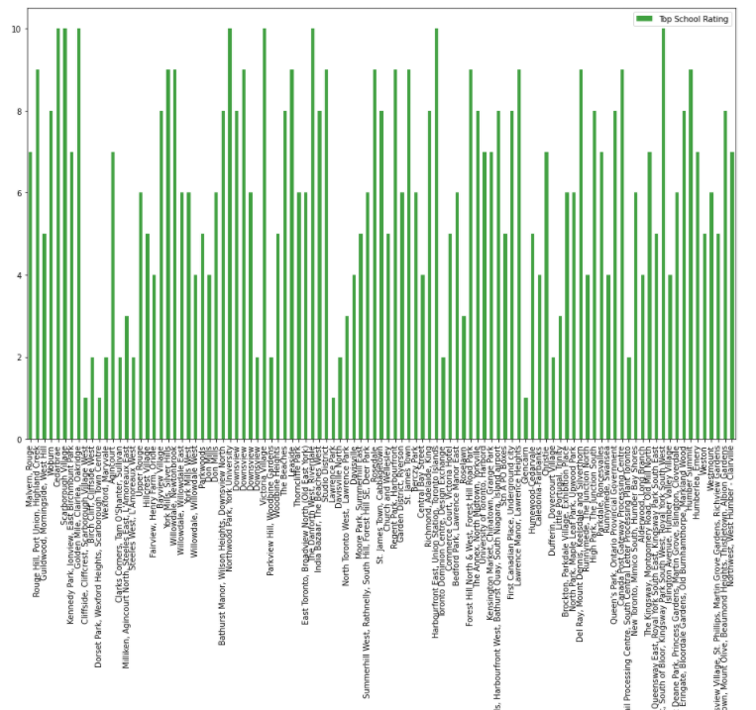

Discussion Section

We used the above results to demonstrate a great neighborhood for an individual to move into. We looked at factors such as the most common venues, average housing pricing, and school ratings.

Conclusion Section

With the utilization of the K-Means cluster method, we have a neighborhood separated into different clusters for a dataset consisting of different latitudes and longitudes. Using python and various libraries, we can present the average house prices and school ratings based on the neighborhood of our selection. This was an amazing final assignment and really made me a lot knowledgeable at data science and python programming language.